Gambia, The

## Population Data

The data set shows the political stability estimate of the country each year.

## # A tibble: 23 x 5  
## country iso3c date population popCategory5  
## <chr> <chr> <dbl> <dbl> <chr>   
## 1 Gambia, The GMB 1996 1164091 very small   
## 2 Gambia, The GMB 1997 1200526 very small   
## 3 Gambia, The GMB 1998 1238125 very small   
## 4 Gambia, The GMB 1999 1277133 very small   
## 5 Gambia, The GMB 2000 1317703 very small   
## 6 Gambia, The GMB 2001 1360074 very small   
## 7 Gambia, The GMB 2002 1404261 very small   
## 8 Gambia, The GMB 2003 1449925 very small   
## 9 Gambia, The GMB 2004 1496527 very small   
## 10 Gambia, The GMB 2005 1543741 very small   
## 11 Gambia, The GMB 2006 1591445 very small   
## 12 Gambia, The GMB 2007 1639848 very small   
## 13 Gambia, The GMB 2008 1689285 very small   
## 14 Gambia, The GMB 2009 1740279 very small   
## 15 Gambia, The GMB 2010 1793196 very small   
## 16 Gambia, The GMB 2011 1848147 very small   
## 17 Gambia, The GMB 2012 1905011 very small   
## 18 Gambia, The GMB 2013 1963711 very small   
## 19 Gambia, The GMB 2014 2024042 very small   
## 20 Gambia, The GMB 2015 2085860 very small   
## 21 Gambia, The GMB 2016 2149139 very small   
## 22 Gambia, The GMB 2017 2213894 very small   
## 23 Gambia, The GMB 2018 2280102 very small

# Population growth data

## # A tibble: 23 x 5  
## country iso3c date popGrowth popGrowthCat5   
## <chr> <chr> <dbl> <dbl> <chr>   
## 1 Gambia, The GMB 1996 3.10 high growth rate  
## 2 Gambia, The GMB 1997 3.08 high growth rate  
## 3 Gambia, The GMB 1998 3.08 high growth rate  
## 4 Gambia, The GMB 1999 3.10 high growth rate  
## 5 Gambia, The GMB 2000 3.13 high growth rate  
## 6 Gambia, The GMB 2001 3.16 high growth rate  
## 7 Gambia, The GMB 2002 3.20 high growth rate  
## 8 Gambia, The GMB 2003 3.20 high growth rate  
## 9 Gambia, The GMB 2004 3.16 high growth rate  
## 10 Gambia, The GMB 2005 3.11 high growth rate  
## 11 Gambia, The GMB 2006 3.04 high growth rate  
## 12 Gambia, The GMB 2007 3.00 high growth rate  
## 13 Gambia, The GMB 2008 2.97 high growth rate  
## 14 Gambia, The GMB 2009 2.97 high growth rate  
## 15 Gambia, The GMB 2010 3.00 high growth rate  
## 16 Gambia, The GMB 2011 3.02 high growth rate  
## 17 Gambia, The GMB 2012 3.03 high growth rate  
## 18 Gambia, The GMB 2013 3.03 high growth rate  
## 19 Gambia, The GMB 2014 3.03 high growth rate  
## 20 Gambia, The GMB 2015 3.01 high growth rate  
## 21 Gambia, The GMB 2016 2.99 high growth rate  
## 22 Gambia, The GMB 2017 2.97 high growth rate  
## 23 Gambia, The GMB 2018 2.95 high growth rate

## Population trend

The plot shows the population trend of the country.

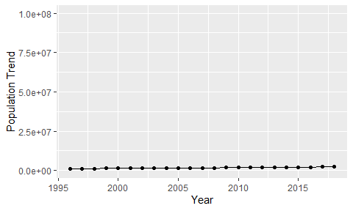

Political Stability Trend

# Population growth trend

The plot shows the population growth rate trend of the country.

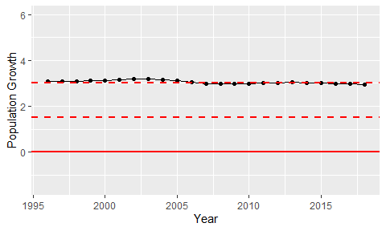

Population Growth Trend